Merry Christmas to all Southhill Artists
December 6, 2018 11-2 is almost here!!!
Save the date!!!! Don’t forget December 6th is our annual Christmas potluck exchange party starting at 11:00. Bring your exchange gift that could be an art supply or something useful or fun.
Our Charity this year is AAUW the American Association of University Women - Puyallup Valley Branch. We have implemented the garden tour as an ongoing fundraiser for the branches STEM Ed projects to benefit area girls.
We will raffle (1) donated original painting by Eric Weingardt for $5.00 each. Painting valued at $275.00 and titled

“Flower Market in Nice”

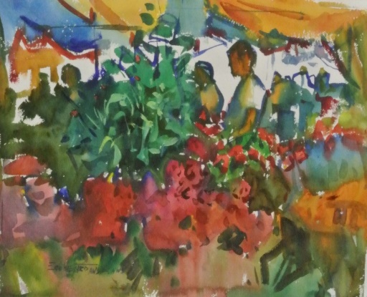

We will also raffle (2) beautiful bikes donated by Ruby Harr for our charities. Thank you Ruby! Raffle is for $1.00 ea

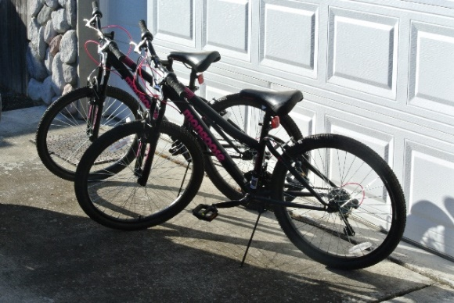

Winners will be pulled on our February 7th 2019 SHA meeting.

