Presidents Note

Dear South Hill Artists

Our next SHA demo on April 7th 2022.is Kathleen Moore presenting a Value and thumbnails study and for May 5th 2022 is watercolorist Kathy Collins. At the First Presbyterian Church of Puyallup 10-2. The requirements may still be at time is to wear your masks and no eating in the facility. But this may change now that restrictions have been listed. There is a picnic table, you can bring a chair outside or eat in your car. You will be able to sip water by lifting your mask and reapplying. Also we would like to see all our members vaccinated.

The First Presbyterian Church of Puyallup located at 412 West Pioneer Puyallup, WA 98371.

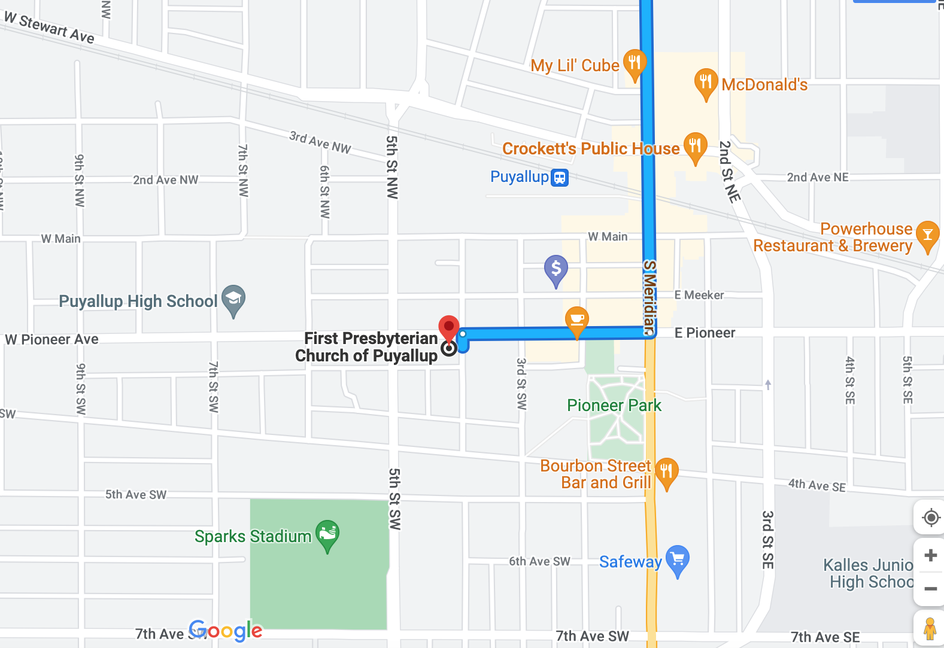

There is parking behind the church. Please do not come too early. The doors located in the back of the building off from the parking lot will not be open until 10:00. The bathrooms are located down the hall from our meeting room.
To all Great News!!! SHA Camp Arnold campers we have our old dates back. Dates for spring camp are April 25th -29^{th 2022}. Cost for 4 nights, 9 special meals, snacks and great art fun. For a double room it will cost is $350. For a single room it will be $390. $100.deposit holds your space. Final payment will be due or before April 7th 2022. Nonrefundable by March 25th. I’m very excited to be able to go back to camp. There may be some restrictions but we can work out the details. It will be easy if you are vaccinated.

April 7th demo artist is Kathleen Moore

When I become still and look closely at what is around me, it is like walking into another world. It is that world, that perspective that I love to paint.”
Kathleen Moore is a visual artist who paints and draws with a variety of materials to capture moments of awe, from vast, stormy skyscapes to the intimate amazement by a single flower. "The natural world," Moore explains, "has an overwhelming power to make you stop and and reconsider your position and role on the planet. I paint and draw to record a sensation of interconnectedness and fragility of life. This is why the arts are so important, they serve as reminders that we are at once greater, and lesser, than we believe. “Challenging belief, or what we believe we see, is a recurring theme in the classes and workshops Moore teaches. “I’m like a fitness coach," Moore chuckles, "I get students moving with exercises to build their skills in drawing and painting, then we do the "yoga" part where students learn to stretch how and what they perceive. “Originally from Texas, Moore has lived in the Seattle area since 1990. She received her BA in art from West Texas A&M University then continued her study of painting at Bruchion School in Los Angeles, CA and Gage Academy of Art in Seattle, WA.

Supplies:

- White paper sketchbook
- Black paper (can be construction paper)
- Graphite pencils
- White “charcoal” or pastel pencil
- Black Tombow Dual Brush Pen Art Marker (or similar)
- Printed (8.5x11 inch) color photo – preferably one you have taken and might use as reference for a painting. Just use regular printer paper, we will be drawing on this print.
- Print and follow directions on “Value.pdf”

May 5th 2022 Demo artist is Kathy Collins

Kathy always had a pencil in her hand while growing up, sketching pictures of her surroundings in Seattle and environs. Later as a college student she was fascinated by the natural environment including people, animals, and plants and studied both biology and art. Hiking in the mountains of Washington was a favorite activity.
Having grown up in a family where art was considered frivolous, she was encouraged to study something “practical.” So after graduation in Biology at the University of Washington, she went on to enroll at Dartmouth Medical School and later transferred to the University of Michigan Medical School in order to be near her fiancée who would be doing an internship in Internal Medicine. Kathy received her MD degree, she and Steve married, and they moved to the Washington DC area where she trained in the specialty of Physical Medicine and Rehabilitation. She and Steve (who had earlier completed his training in Oncology) and their growing family of 3 boys moved back to Washington State. Steve headed up a research lab at the Fred Hutchinson Cancer Research Center and Kathy practiced medicine part-time while they raised their sons. She limited her practice to the diagnosis of nerve and muscle injuries.
While the study of science was interesting and she enjoyed the contact with patients and staff, the day to day practice of medicine did not provide an outlet for creativity. Kathy felt that she had missed her calling. She picked up a pencil again, and in the mid-1980’s studied Scientific Illustration at the University of Washington. Her love of the outdoors led her to paint precisely rendered images of the natural world, especially botanical subjects.
As her boys grew and left for college and careers, she had more time to devote to painting. Kathy’s style evolved to more impressionistic images inspired by sketches made while she and Steve hiked the mountains and shores of Washington State and on their many bicycle trips in the US and Europe. Painting became her primary focus and she began showing her watercolors in juried shows, achieving Signature status in The American Watercolor Society, The Northwest Watercolor Society, and Women Painters of Washington
She and Steve were very proud of their sons: the oldest, Jeff, completed his PhD in Physics from the University of California at Berkeley and works for a multinational firm in data analysis; Greg graduated from West Point, served his country in Iraq, and now is the owner of a web design business as well as on-line sporting goods company; James is a Structural Engineer with a company that is currently working on King County Light Rail. Sadly Steve became ill, his condition gradually worsened, and he passed away in May, 2017.
Kathy’s painting has been therapeutic for her at this difficult time. She is currently adding collage and encaustic (wax) media to her watercolor techniques. She teaches classes and workshops at Tsuga Fine Art in Bothell, participates in local arts groups, and exhibits her work in galleries and juried shows. She continues to hike and bike and enjoys spending time with her friends and family, which now includes 4 grandchildren.
Her next show opens at the Gallery here in the Lake Forest Park Town Center on Thursday, Feb. 22nd 5-7PM. The show will be up through March 31st. Her work can be seen at www.kathycollinswatercolors.com

SUPPLY LIST

Watercolor paper 140# cold press, Fabriano Artistico or Arches, 1 or more sheets, plus Gatorboard or other non-absorbent board and tape or clamps to support and hold the paper
Watercolor paint: Winsor & Newton preferred, but most brands will work —French ultramarine blue, cerulean blue, alizarin crimson, raw sienna, burnt sienna, sepia or burnt umber
Brushes: large flat 1 ½” or 2” (I use synthetic), one small brush such as a rigger for fine lines
Palette - preferably one with large wells (eg Sterling Edwards) to accommodate the large brushes
Water container, and small Spray bottle for “spritzing”
Towels or large sponge (for sopping up extra water) – important!
Sketchbook/pens (eg Sharpie ultrafine point) for value studies
Photos or sketches (to paint from) - optional
Pencils, kneaded eraser
Drafting tape (not masking tape)

